Selenium practice

Selenium

1. Install of jar files
2. Lunch chrome and Firefox

System.*setProperty*("webdriver.chrome.driver", "C:\\chromedriver.exe");

ChromeDriver driver = **new** ChromeDriver();

System.setProperty("webdriver.gecko.driver","D:\\Firefox\\geckodriver.exe");

WebDriver driver = new FirefoxDriver();

**3 Select Drop Down**

Select drpCountry = new Select(driver.findElement(By.name("country")));

drpCountry.selectByVisibleText("ANTARCTICA");

//Selecting Items in a Multiple SELECT elements

driver.get("http://jsbin.com/osebed/2");

Select fruits = new Select(driver.findElement(By.id("fruits")));

fruits.selectByVisibleText("Banana");

fruits.selectByIndex(1);

Writing Xpath

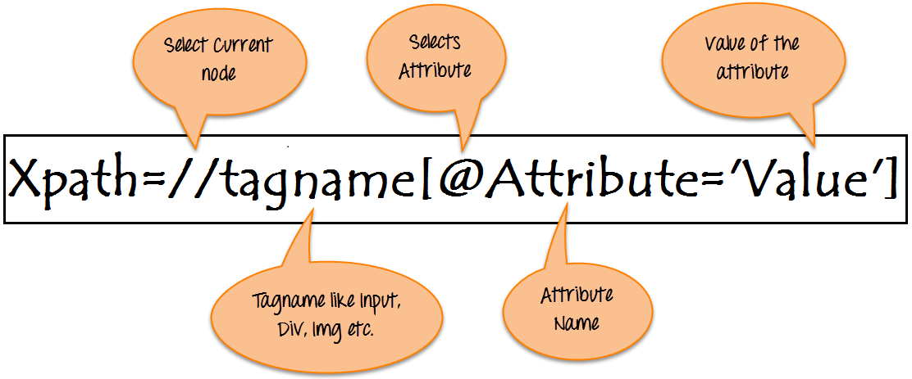

**Syntax for XPath:**

XPath contains the path of the element situated at the web page. Standard syntax for creating XPath is.

Xpath=//tagname[@attribute='value']

* **// :** Select current node.
* **Tagname:**Tagname of the particular node.
* **@:** Select attribute.
* **Attribute:** Attribute name of the node.
* **Value:** Value of the attribute.

Chrome extention = xpath helper